Social Media Content – Draft 2

**Purpose**: Social media is an easy and cost effective (free) way to generate awareness. Interested parties can post the provided content on their social media platforms to spread awareness about HearMeWA to their networks.

* Up to six static images
* Suggested social media post copy per still image

## Post 1: Introducing HearMeWA

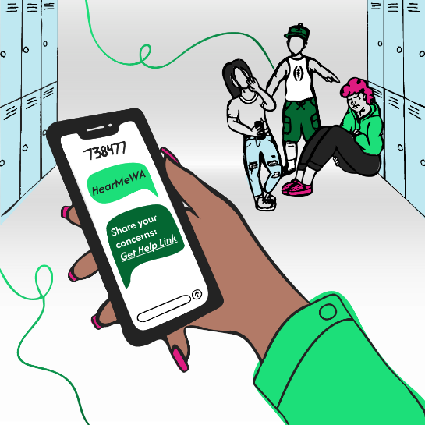**Post Copy**

*HearMeWA is a new statewide support line for Washington youth! If you’re dealing with bullying, anxiety, or just need someone to talk to, HearMeWA is ready 24/7 to help. You can share your concern by phone, text, online, or through the app—anonymously if you choose.*

*Learn more at HearMeWA.org and spread the word! #HearMeWA #YouthSupport #YouthMentalHealth #YouthSafety*

## Post 2: Accessible Support

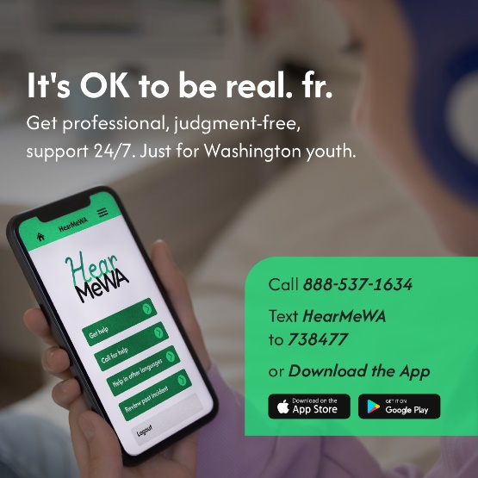**Post Copy**

*Need support? HearMeWA makes it easy to reach out, no matter the issue. Connect with trained counselors anytime, anywhere. It’s anonymous, confidential, and available 24/7. Washington youth up to age 25 can download the HearMeWA app today from the App Store or Google Play. #MentalHealthMatters #HearMeWA*

## Post 3: Why HearMeWA Matters

**Post Copy:**

*No matter where young people live—rural, urban, or anywhere in between—HearMeWA is ready to help. This new statewide helpline offers support for issues like depression, bullying, suicidal ideation, and violence.*

*Please share this resource with your community: call, text, or visit HearMeWA.org to get connected. #HearMeWA #YouthSupport #YouthMentalHealth #YouthSafety*

## Post 4: Support for All Issues

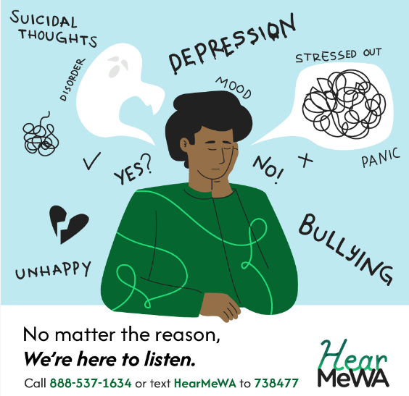**Post Copy:**

*Whatever challenges youth in your community are facing—whether it’s bullying, anxiety, or housing insecurity—HearMeWA is here to listen and provide support. Their trained counselors are ready to connect young people with the right resources.*

*Spread the word! Encourage youth to visit HearMeWA.org or text 738477 to get started. #YouthSupport #MentalHealth*

## Post 5: Youth-Centered & Inclusive

**Post Copy:**

*HearMeWA isn’t just for young people—it’s made by them. Starting with the vision of a college student from Kennewick, HearMeWA was designed with direct input from youth and young adults across Washington.*

*This statewide helpline is committed to being youth-centered, antiracist, and trauma-informed. Through the guidance of the HearMeWA Youth Advisory Group, the program reflects the voices and needs of young Washingtonians from all backgrounds.*

*Share this resource with the youth in your community and learn more at HearMeWA.org. #YouthSupport #TraumaInformed #Inclusive*

## Post 6: How to File a Report

**Post Copy:**

*Do you know a young person in need of support? Getting help with HearMeWA is simple:*

1. *Visit HearMeWA.org*
2. *Click ‘Get Help’*
3. *Get connected with a counselor*

*They can also call or text 24/7 for help. Let’s make sure everyone knows about this important resource. #HowToHelp #HearMeWA*