AGO HearMeWA
Translation table: Social Media Post Copy
Spanish and Simplified Chinese
Sections in red do not need to be translated
English | Chinese
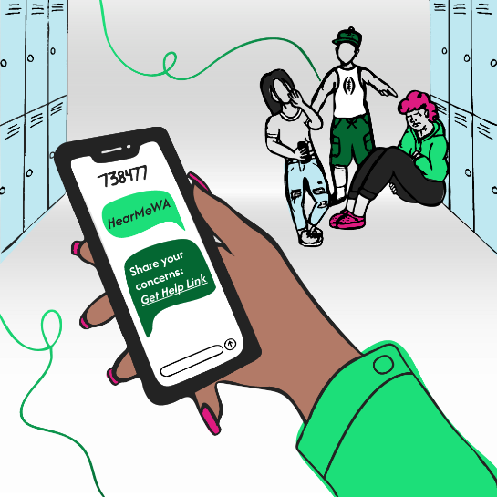  Image for social media post for reference | Image for social media post for reference
Share your concerns: Get Help Link | 说出你的顾虑：获取帮助链接
HearMeWA is a new statewide support line for Washington youth! If you’re dealing with bullying, anxiety, or just need someone to talk to, HearMeWA is ready 24/7 to help. You can share your concern by phone, text, online, or through the app—anonymously if you choose. | HearMeWA 是一条针对 Washington 州青年的全新全州支持热线！如果你正面临霸凌、焦虑，或者只是需要找人倾诉，HearMeWA 随时准备提供帮助。你可通过电话、短信、网上或应用程序说出你的顾虑——如果你需要，可以保持匿名。
Learn more at HearMeWA.org and spread the word! #HearMeWA #YouthSupport #YouthMentalHealth #YouthSafety | 请前往 HearMeWA.org 以了解更多信息，并传播这个消息！ #HearMeWA#YouthSupport #YouthMentalHealth #YouthSafety
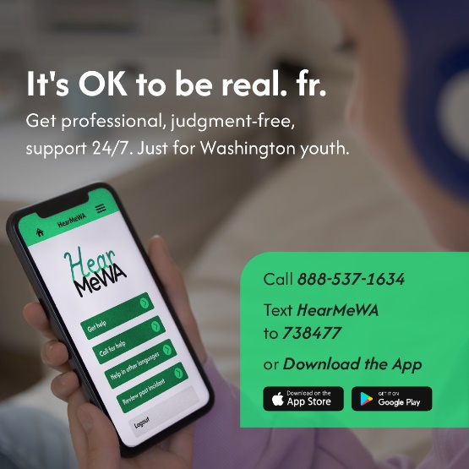  Image for social media post for reference | Image for social media post for reference
It’s OK to be real. fr. | 真实一点就好。真的
Get professional, judgment-free, support 24/7. Just for Washington youth. | 获得专业、无偏见的全天候支持。仅限 Washington 州青年。
Need support? HearMeWA makes it easy to reach out, no matter the issue. Connect with trained counselors anytime, anywhere. It’s anonymous, confidential, and available 24/7. Washington youth up to age 25 can download the HearMeWA app today from the App Store or Google Play. #MentalHealthMatters #HearMeWA | 需要支持吗？HearMeWA无论是什么问题，都可以轻松解决。随时随地与训练有素的顾问联系。热线是匿名的、保密的，且全天候提供服务。Washington 州 25 岁以下的青年均可从 App Store 或 Google Play 立即下载 HearMeWA 应用程序。#MentalHealthMatters #HearMeWA
No matter where young people live—rural, urban, or anywhere in between—HearMeWA is ready to help. This new statewide helpline offers support for issues like depression, bullying, suicidal ideation, and violence. | 无论年轻人住在哪里——农村、城市或两者之间的任何地方——HearMeWA 随时准备提供帮助。这条新的全州帮助热线，为抑郁症、霸凌、自杀意念和暴力等问题提供支持。
Please share this resource with your community: call, text, or visit HearMeWA.org to get connected. #HearMeWA #YouthSupport #YouthMentalHealth #YouthSafety  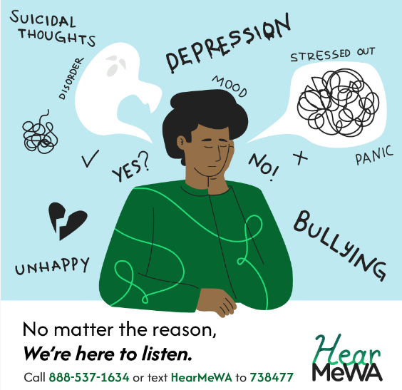  Image for social media post for reference | 请与您的社区分享此资源：致电、发送短信或访问 HearMeWA.org 进行联系。#HearMeWA #YouthSupport #YouthMentalHealth #YouthSafety  Image for social media post for reference
No matter the reason | 无论什么原因
We’re here to listen. | 我们在这里聆听你的倾诉。
Call 888-537-1634 or text HearMeWA to 738477 | 拨打 888-537-1634 或发送文本 HearMeWA 至 738477
Whatever challenges youth in your community are facing—whether it’s bullying, anxiety, or housing insecurity—HearMeWA is here to listen and provide support. Their trained counselors are ready to connect young people with the right resources. | 无论社区里的年轻人面临什么挑战——无论是霸凌、焦虑还是住房不安全——HearMeWA 在这里倾听并提供支持。他们训练有素的辅导员随时准备为年轻人提供适宜的资源。
Spread the word! Encourage youth to visit HearMeWA.org or text 738477 to get started. #YouthSupport #MentalHealth #HearMeWA | 传播这个消息！鼓励年轻人访问 HearMeWA.org ，或发送文本 738477 以开始。#YouthSupport #MentalHealth #HearMeWA
Image for social media post for reference  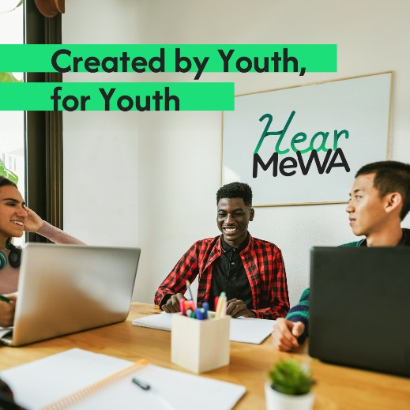 | Image for social media post for reference
Created by Youth, for Youth | 由青年设立，为青年服务
HearMeWA isn’t just for young people—it’s made by them. Starting with the vision of a college student from Kennewick, HearMeWA was designed with direct input from youth and young adults across Washington.  This statewide helpline is committed to being youth-centered, antiracist, and trauma-informed. Through the guidance of the HearMeWA Youth Advisory Group, the program reflects the voices and needs of young Washingtonians from all backgrounds.  Share this resource with the youth in your community and learn more at HearMeWA.org. #YouthSupport #TraumaInformed #Inclusive | HearMeWA并不仅仅为年轻人服务——它也是由年轻人设立的。从一位来自 Kennewick 的大学生的愿景开始，HearMeWA 其设计直接参考了 Washington 州各地青年和年轻人的意见。  这条覆盖全州的热线致力于以青年为中心、反对种族主义、并关注创伤。通过 HearMeWA 青年顾问小组，该计划反映了来自各行各业的 Washington 州年轻人的声音和需求。  与你所在社区的年轻人分享此资源，并前往 HearMeWA.org 以了解更多信息。#YouthSupport #TraumaInformed #Inclusive

